



**Proposal and Specification for:**

**Mobile Application Development for HICT**

Pharmacovigilance – Report on safety and adverse events

Presented by

**Andolasoft**

HQ & West Coast  
2059 Camden Ave. #118,

San Jose, CA

95124  
USA

Submitted to:

**Jan Demey**

Managing Director

HICT

Presented by:

**Jayadev Das**

VP - Global Delivery

*Date: 08th June, 2016*

Hello,

It is with great pleasure that I present to you our proposal. Having recently developed an in-depth understanding of the HICT company vision, I believe Andolasoft would be an ideal partner to design and develop the Mobile application for HICT. Our team of expert developers and creative talent are a perfect match to meet the technical and aesthetic vision of HICT.

Our proven track record for projects large and small, including numerous startups, gives us the ability to create a product based on prior successes as well as collective insight.

We appreciate your consideration and confidence. Please contact Mr. Jayadev Das at jayadev.das@andolasoft.com with any questions.

Best Regards,

Jayadev Das

VP Global Delivery, AndolaSoft

[www.AndolaSoft.com](http://www.AndolaSoft.com)

**Executive Summary**

This Business Proposal represents a combination of strategic guidance as well as best practices in user experience design and development for the Mobile application.

Based on the briefing with project RFP, we understand the goal of our initial engagement is the development of a functioning mobile application which will be developed for Android & iOS platform.

**TABLE OF CONTENT**

1 Company Profile 4

2 Case Study – AuditNet mobile application development 5

3 Company Portfolio 6

4 Project scope, Proposed Milestone & Strategy 12

High Level Architecture Diagram 13

Deliverables & Milestones: 13

5 Team structure 15

6 Project Timeline & Cost Estimation 15

7 Payment Method and Phases 15

8 Support & maintenance plan for mobile app 15

9 Change Request Process 16

10 Terms & Conditions 16

# Company Profile

**Who we are**

We are a dynamic Web & Mobile development company based in San Jose, CA having development centre in India. We design, develop Web, iPhone, iPad, Android Apps for start-ups & established businesses. We are agile and do help clients by delivering projects in time and within budget. We believe in quality work done by our experienced resources. We have satisfied customers spread across the USA, Canada, Australia, UK, Singapore & Brazil. Andolasoft awarded as best mobile app Development Company by ***Mashable*** in ***June 2014***.

**What we do**

Andolasoft is providing you the opportunity to move out of your cubicle and use the amazing mobile apps and services developed by us. Our innovative and creative developers understand the requirement of our clients and choose a most optimized beneficial solution and then convert that into a product. We're developing apps featuring maps, store locators, online orders & bookings, social sharing, product or service rating and many others. Currently we're developing apps for iPhone, iPad & Android smartphones.

**Why choose us**

The company values stand on the understanding that our success is tied to the success of our clients. We work closely with our customers to ensure that we meet the service levels on the most CTQ parameters of **'flawlessness'**, '**within budget**' and '**on time'** application development along with strong security measures to safeguard customer data and information.

**Our Strategy**

Our strategy is simple. We stick to an agile process flow, which includes seven critical steps: Unearth >> Design >> Develop >> QA >> Launch >> Measure >> Iterate

# Case Study – AuditNet mobile application development

**Introduction**

AuditNet serves the global audit community as the primary communications resource with an online digital network where auditors share resources, tools, and experiences including audit work programs and other audit documentation. The AuditNet web application is designed to handle larger user base and online payments for the subscription plans.

**Problem**

Due to the growth of smartphone application usages, there was an opportunity for AuditNet to attract smartphone users looking for audit application. Also the smartphone application would help the existing users to seamlessly access the audit tools/contents inside their smartphone application without need to browsing the website.

**Analysis & Recommended solution**

Andolasoft helped AuditNet to analysing the audit industry and the website for the smartphone application development. Andolasoft proposed a cost effective solution for AuditNet to develop a smartphone application which will run on all the major platforms like iOS, Android and Windows.

**Implemented Solution**

Andolasoft developed the mobile app as well as the backend API endpoints which communicates to the AuditNet web platform. The mobile application development completed within 10 weeks of the timeframe. Andolasoft also helped AuditNet to place the smartphone application on the respective market places for iOS, Android and Windows. For iOS, Apple’s inApp purchase is implemented and for Android & Windows platform we have implemented the PayPal payment system like the web. The mobile app also has the functionality to download the audit templates/tools and access it from the app itself.

**Results**

The smartphone app developed by Andolasoft helped the AuditNet users to use the Audit templates/tools easily. Due to the integrated payment system users are also able to renew/upgrade the subscription plans seamlessly. This flexibility of the mobile app increased the user conversion ratio of AuditNet to 80% growth.

# Company Portfolio

Some of our Recently Developed iPhone/iPad applications

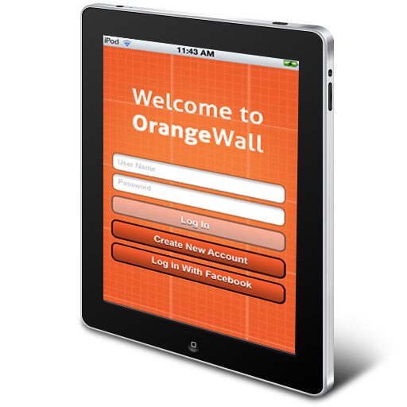

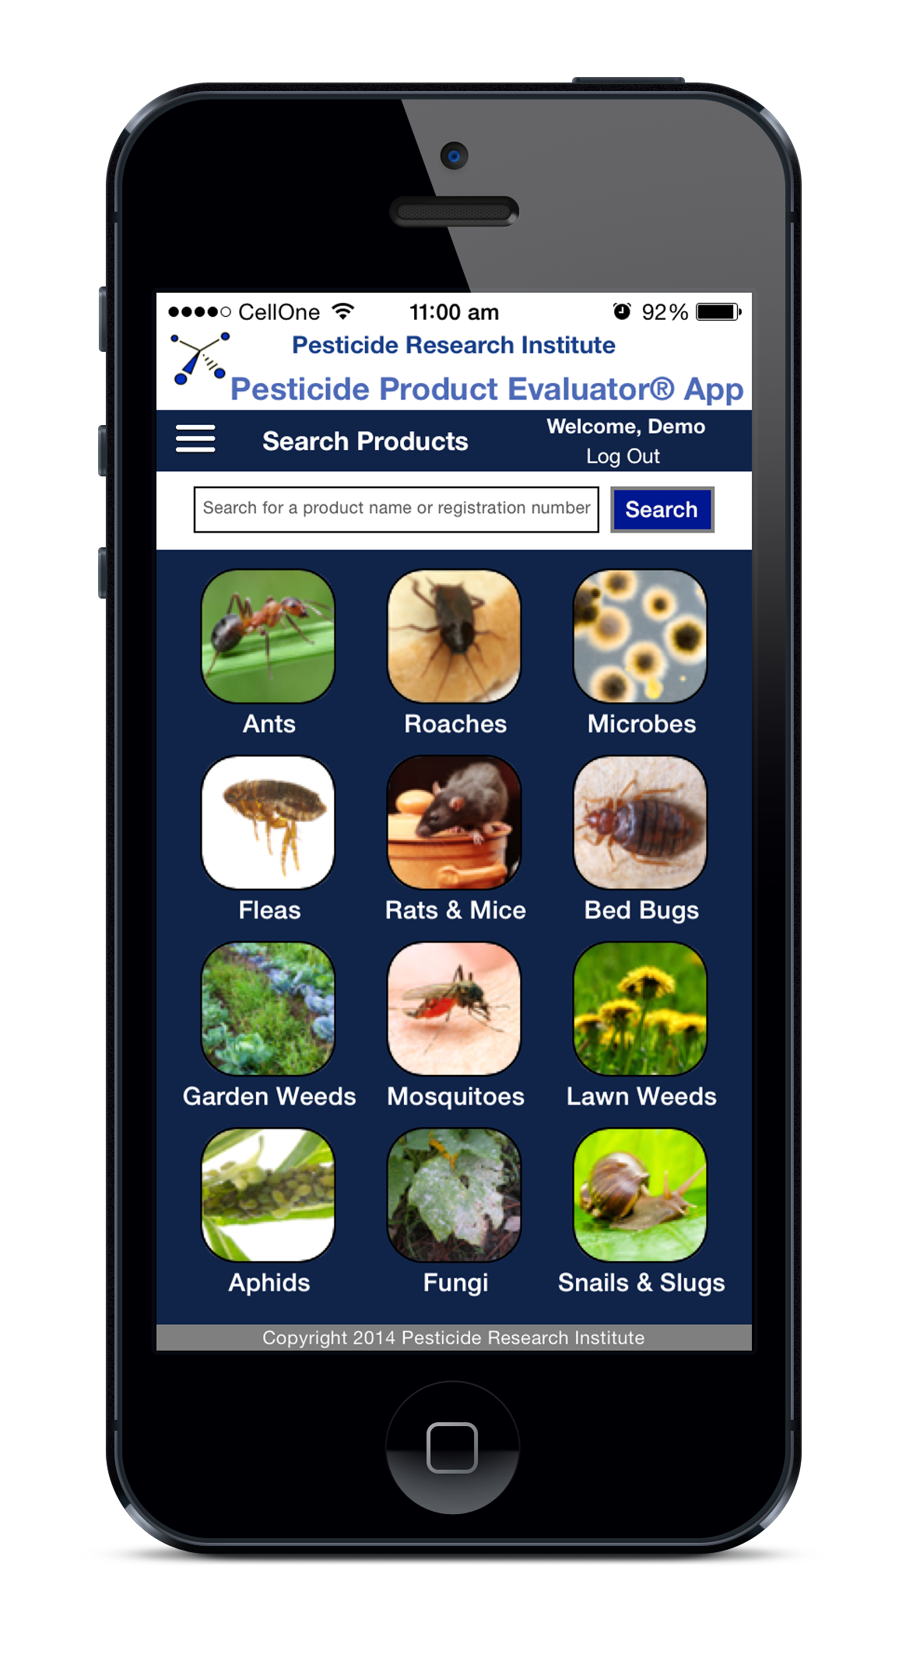

 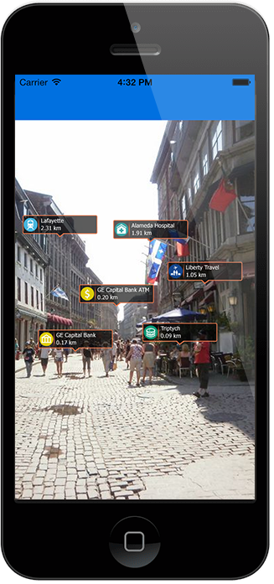

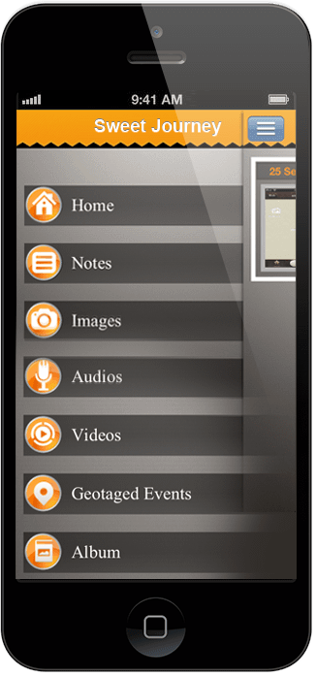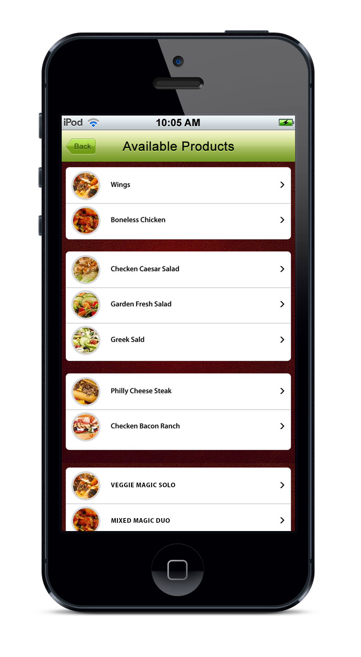

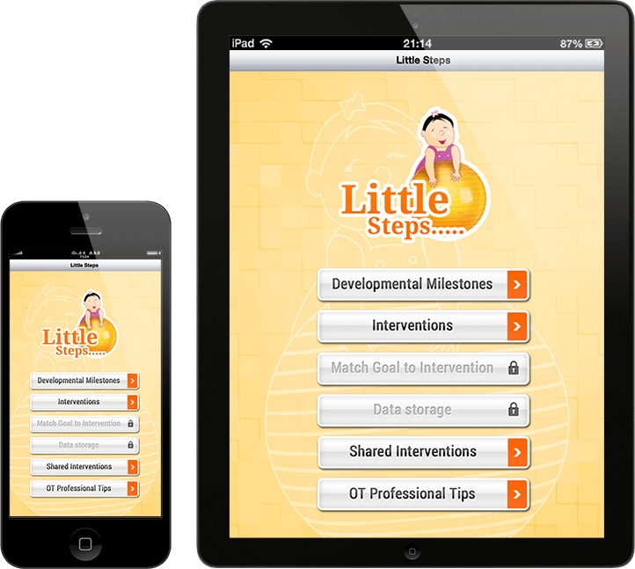

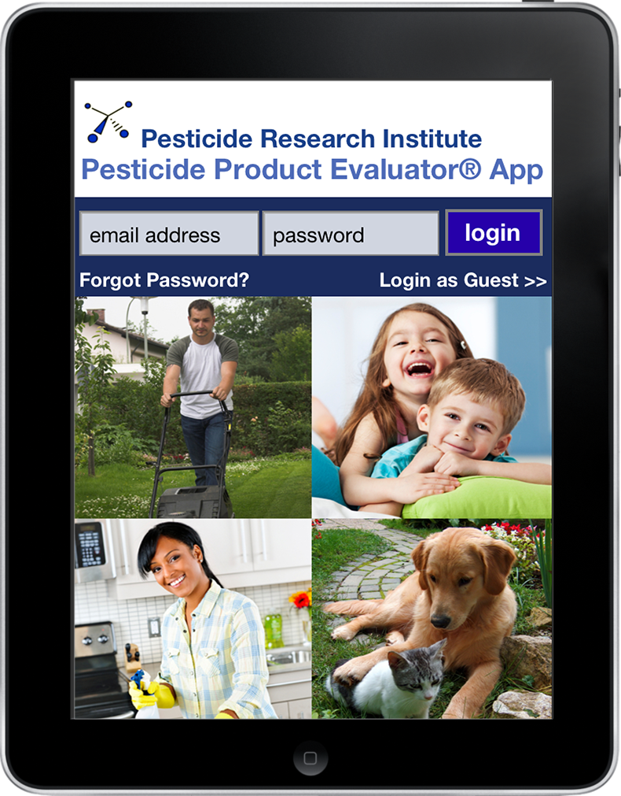

Some of our Recently Developed Android Apps

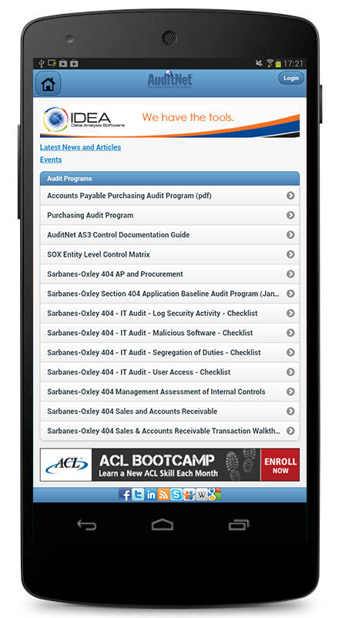 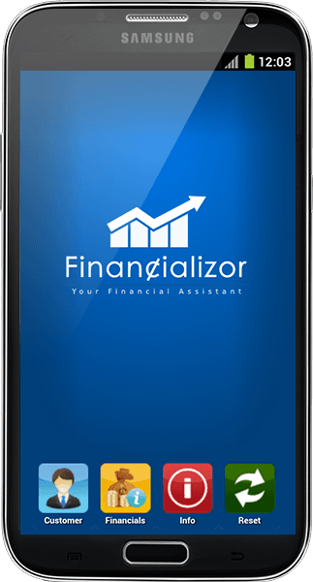

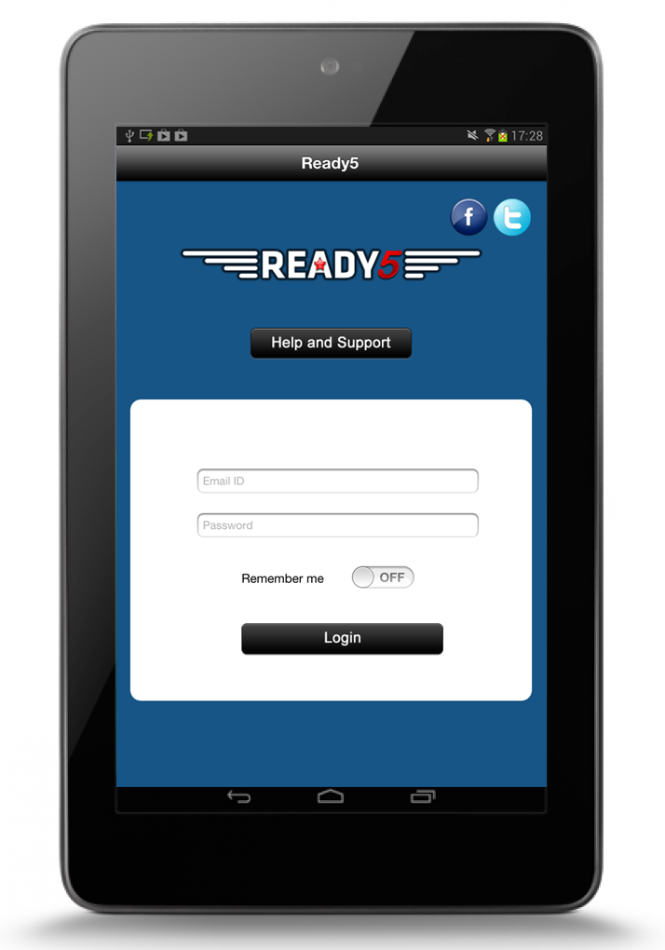

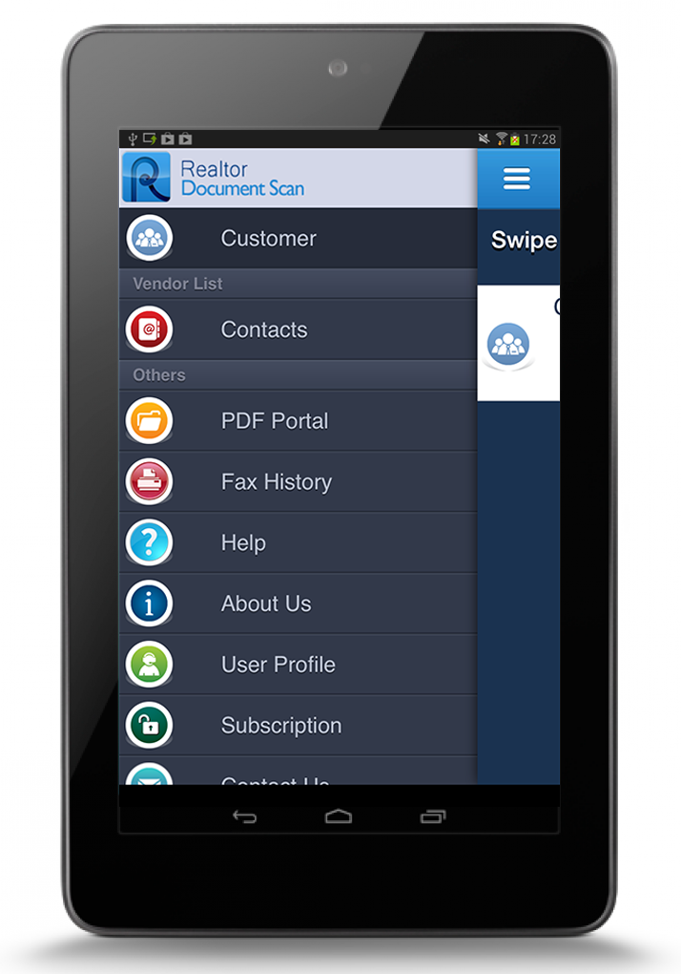

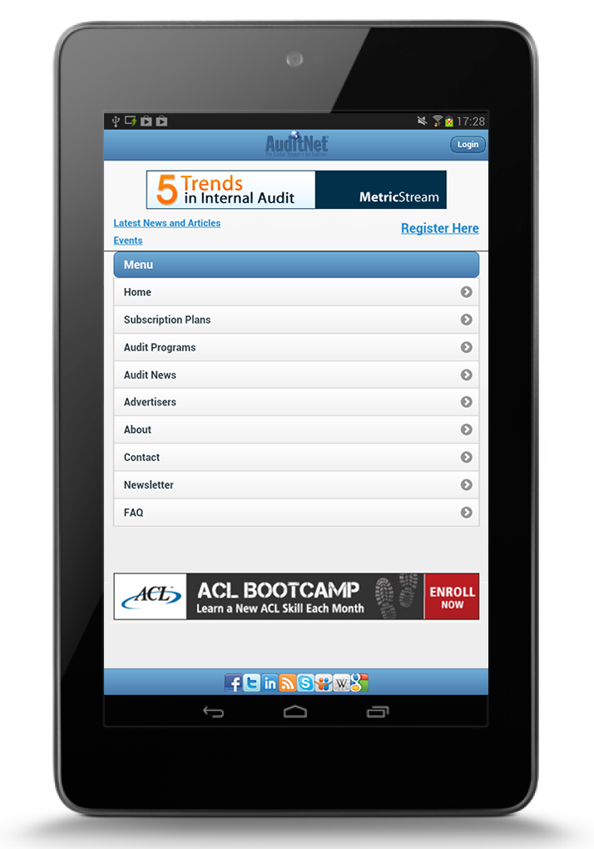

# Project scope, Proposed Milestone & Strategy

The specifications listed below outline the scope of work to be completed for the Mobile application. The mobile application will be developed in ***native platforms*** to run on both Android & iOS platform. The Webservice & Webportal will be developed using ***Ruby on Rails*** technology

The purpose of this mobile application is to replace a paper and existing web form with a simple mobile app which will allow Physician/Nurses/Pharmacists to fill up a form which will help to report safety and adverse event topics concerning pharmaceutical products of the client. All the pharmaceutical products will be uploaded / updated by the pharmaceutical company on a web base portal. This web base portal will be protected through a username & Password to restrict the unauthorized access. All the pharmaceutical products uploaded will be stored on cloud database securely. The mobile app will collect all the product information through Webservice API, which will collect from the secure cloud database. After the form is filled up by the Physician/Nurses/Pharmacists on the mobile app, all the information will be saved into the cloud database for further data mining through a secure webservice API. All the data transfer from mobile to webservice API will be encrypted for enhanced security. The mobile app automatically generates a PDF for the completed report of the patient data & Email the PDF report to a generic address of the pharmaceutical company.

The mobile application will have the following functionality

1. **Form Fill up**

User will be allowed to fill up patient information and other fields for selected products.

1. **PDF Report**

After the successful form fill up by the user a PDF generated with all patient information and sent to a generic address of the pharmaceutical company.

The Web portal will have the following functionality

1. **User authentication**

The user will require a username and password to log into the web portal.

1. **Change/Forgot Password**

User can always change or reset the password.

1. **Manage Products**

User can upload products through an excel sheet having a predefined format. User can see the list of products uploaded and can manage it.

## High Level Architecture Diagram

The following image illustrates the high level architecture diagram



## Deliverables & Milestones:

**Release#1 (3 Weeks)**

**Initial Setup**

* Project Kick off meeting
* Development environment setup for Web portal & Mobile app
* UI & UX develop
* API documentation go through
* Application architecture & process flow design
* Database design

**Web Portal Authentication**

* Admin user setup
* User authentication functionality for Web portal
* User dashboard
* User management

**Product Manage**

* Product upload functionality
* Product Listing
* Report generation with date ranges

**Webservice API development**

* User authenticate
* To get Product listing
* To save patient report

**Mobile App**

* To create click through mock up for the form design

**Demo**

* Preparing first revision for Web portal & Click through mockups for mobile app
* Customer feedback & bug fixe process

**Release#2 (3 Weeks)**

**Mobile App - Register devices**

* API integration to send or get device info

**Mobile App - User Authentication & Form Fill up**

* User authentication form design and API integration
* Displaying of the Form to fill data for a patient
* PDF generation after successful form fill up
* Email sent to pharmaceutical company with generated PDF

**Demo**

* Preparing first revision build for Android & iOS
* Customer feedback & bug fixe process

**Release#3 (2 Weeks)**

**Mobile App - Offline data and Security**

* Data connection availability check
* Save the current data in device storage if failed to save in cloud database
* Data Sync after internet connection availability
* Data encrypt while communicating with webservice API

**Demo**

* Preparing first revision build for Android & iOS
* Customer feedback & bug fixe process

**Mobile App - Deployment to app stores – On 7th Week**

* UAT & Bug fixes
* App crash testing
* Production environment setup for Webportal & Webservice
* Change of configuration for end point webservice API on mobile apps
* Production app build packs for iOS & Android platform
* App deployment to the iTunes & Google Play store

# Team structure

* Project Manager - 1
* Lead developer – 1
* Sr. developer - 2
* QA - 1
* Graphics designer for UI & UX - 1

# Project Timeline & Cost Estimation

To complete the mobile application development would take approximately **8 weeks** of time. The pricing for the development varies depending upon the technology used to develop the mobile application as listed below

* Option#1 – Native (Android & iOS)

***$11,500***

* Option#2 – Hybrid

***$8,500***

# Payment Method and Phases

|  |  |  |
| --- | --- | --- |
| Payment Milestones | % | Amount in **USD** |
| Advance on signing up the contract | 30% |  |
| On completion of the Release#1 demo | 30% |  |
| On completion of the Release#2 demo | 20% |  |
| On completion of the Release#3 demo | 20% |  |

* 30% of advance payment after signing of the contract. 30% of payment after 1st demo done for the release#1. 20% amount need to be released each time after the completion of Release#2 & Release#3 demo.
* All the payment shall be Wire Transfer to the bank details or through Credit Card sent through the invoice.
* The final instalment of the payment shall be released after completion of the mobile app development and before code handover/submitted to respective app stores

# Support & maintenance plan for mobile app

Andolasoft would like to propose for the support and maintenance plan for the developed smartphone application. Following items are covered during the support & maintenance plan.

* Responding to customer queries
* Providing Operating Systems related enhancements
* Ensuring functionality updates
* Support for New Devices
* Support for New OS
* Analytics and monthly Reporting

**Note** – The following pricings are not included on the Pricing section mentioned at Cost estimation

The monthly retainer fee for the support & maintenance plan is ***$999 per month***. There will be free support provided for 16 hours each month during the support & maintenance plan.

The hourly charges after free service is ***$30/hour***

# Change Request Process

Our technical team will analyse every change requests received from client. If the change requires significant time and effort, the same will be notified to client and appropriate effort and schedule slippage will be notified to client for approval.

# Terms & Conditions

* FREE support of 30 days would be provided by Andolasoft for any issues/defects/ to ONLY the features to be delivered as per the specification discussed in Milestone. All the cases will be created in OrangeScrum, technical team member will respond to it.
* Andolasoft would provide free support in order to publish the apps in beta/production version to the respective app stores – iOS & Android
* In order to publish the apps in respective app stores, **HICT**needsto provide respective App store credentials to Andolasoft.
* AndolaSoft would provide free support & service if any issue found during the app publishing process to iTunes & Android play store.
* However, any work unrelated to the scope originally disclosed by **HICT**is chargeable as hourly basis. Rate will be **$30/Hour.**
* It is the sole responsibility of **HICT**to provide legal graphical properties (free from copyright)
* Otherwise, **HICT**can authorise Andolasoft to buy images on their behalf
* Any relevant database or API to be provided by **HICT**on the beginning of the project.
* Feedback loop has to be closed by the **HICT** within 24 hours in-case of weekdays & 48 hours in-case of weekends during development.

IN WITNESS WHEREOF, the parties have executed this Agreement as of the Effective Date.

**For and on behalf of Andolasoft Inc:** **For and on behalf of** **HICT**:

By: _____________________ By: _______________________

Print Name: Priyabrata Gharai Print Name: Jan Demey

As Its: CEO As Its: Managing Director